Time To Complete: 10 to 12 hr

Health Club

**Contents**

1 Problem Statement 2

2 Proposed Health Club Wireframe 3

2.1 Welcome page 3

2.2 View Appointments 3

2.3 Place Appointment 4

2.4 QUERY 4

3 Business-Requirement: 6

4 Constraints 7

5 Mandatory Assessment Guidelines 8

# Problem Statement

Health Club is SPA (Single Page Application) for placing a request for appointment with personal physical trainer, manage appointments and dropping a query

The core modules of Health Club app are:

1. Welcome Page
2. Apply for an appointment
3. View Appointment
4. Query

# Proposed Health Club Wireframe

UI needs improvisation and modification as per given use case and to make test cases passed.

## Welcome page

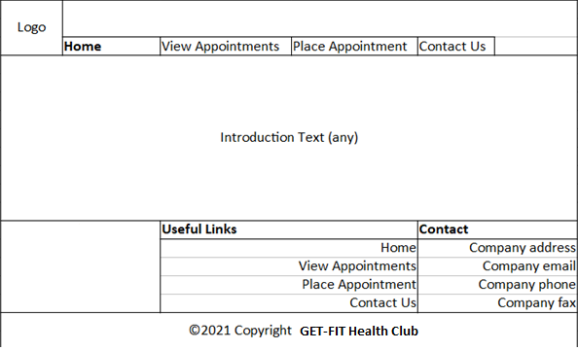

## View Appointments

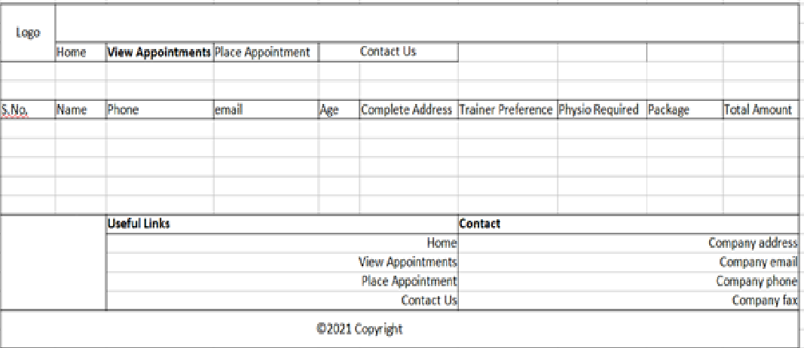

## Place Appointment

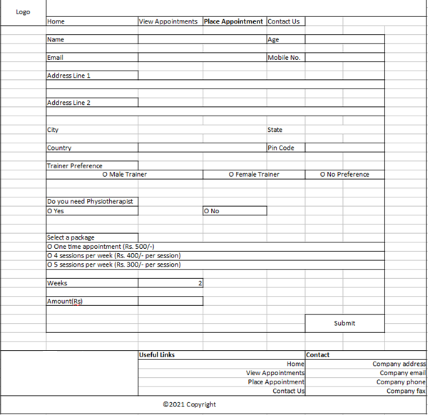

## QUERY

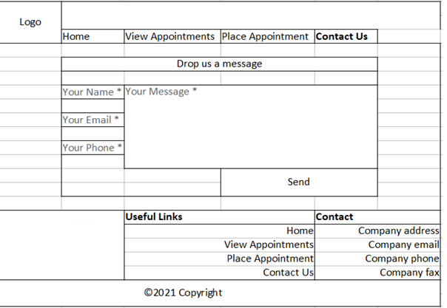

# Business-Requirement:

As an application developer, develop the Health Club App (Single Page App) with below guidelines:

|  |  |  |
| --- | --- | --- |
| User  Story # | User Story Name | User Story |
| US_01 | Welcome Page | As a user I should be able to visit the welcome page as default page.  Acceptance criteria:   1. User can click any button given in the menu bar. |
| US_02 | Post Appointment | As a user I should be able to post an appointment  Acceptance criteria:   1. As a user I should be able to furnish following details at the time of placing an appointment    1. Name    2. Age    3. Email    4. Mobile No    5. Address Line 1    6. Address Line 2    7. City    8. State    9. Country    10. Pin Code    11. Trainer Preference    12. Physiotherapist requirement (Yes or No)    13. Select a package    14. Weeks    15. Amount 2. Weeks number type input box should be visible when 2nd or 3rd package option is selected. 3. If physiotherapist is required add additional 200/- in final amount 4. Amount should be disabled and should be calculated automatically based on the selected package. 5. All details fields must be mandatory. 6. Address line 2 may contain the same address as address line 1. 7. Email& Mobile must be unique. 8. If any constraint is not satisfied, a validation message must be shown. 9. A success or failure message should be visible after the submit button is clicked. |
| US_03 | Manage Appointment | * 1. As a user I should be able to view all appointment requests, and after selecting any appointment   Acceptance criteria:   1. Message should be visible if no appointment is available to show. |
| US_04 | Query | As a user I should be able to post a feedback/query/message  Acceptance criteria:   1. As a user I should be able to furnish following details at the time of filling contact us form    1. Name    2. Email    3. Phone    4. Message 2. Message should not go beyond 200 characters. 3. All four fields must be mandatory. 4. A success or failure message should be visible after the submit button is clicked. |

# Constraints

1. On the page load, input focus must come to the first name input field.
2. You should be able to press the “TAB” key and “SHIFT + TAB” to navigate from top field to bottom field and vice-versa.
3. On click of “Submit” button, appointment details must be saved via fake-rest API in health-club.json.
4. Fake rest api is implemented with json-server.

Example JSON for reference of fields to be used for placing appointment:

{

"firstname": "test",

"lastname": "test",

"age": 24,

"phonenumber": 9988776655,

"email": "test@test.com",

"streetaddress": "test",

"city": "test",

"state": "test",

"country": "india",

"pincode": 560058,

"trainerpreference": "Male Trainer",

"physiotherapist": "Yes",

"packages": "500",

"inr": 1000,

"paisa": 10,

"id": 1

}